**Final Project Test Plan and Results - Sudoku Application**

**Rev. v2.0**

**Abel Tabor, Thomas Edwards, Brian Jefferson**

**CMSC 495**

**Section 7384**

**Group 5**

**5/10/2022**

**Professor Dao**

**Revision History**

| **Name** | **Date** | **Description** |
| --- | --- | --- |
| **Thomas Edwards** | **4/14/2022** | **Started document, added Revision History, added Test Plan Scenario tables, *uploaded documents to GitHub Group Repository.\*** |
| **Abel Tabor** | **4/17/2022** | **Started and completed ICD and started on Test Cases Adding Test Case 1 and 2.** |
| **Thomas Edwards** | **4/19/2022** | **Added Test Cases 3-6. Structured testing in progressive format.** |
| **Abel Tabor** | **4/19/2022** | **Added test case for username input.** |
| **Thomas Edwards** | **4/19/2022** | **Added overview of game operation and denoted key error handling scenarios to be tested.** |
| **Brian Jefferson** | **4/29/2022** | **Added hardware, and software requirements** |
| **Thomas Edwards** | **5/2/2022** | **Revised as “Project Test Plan & Results”. Project Analysis, Design, and ICD will become separate docs.** |
| **Thomas Edwards** | **5/4/2022** | **Started final revision doc (v2.0). Updated Cover page and dates for final submission.** |
| **Thomas Edwards** | **5/7/2022** | **Added pictures for additional documentation** |
| **Brian Jefferson** | **5/7/2022** | **Added Project Test Case 7** |
| **Brian Jefferson** | **5/7/2022** | **Updated System Requirements** |

**Test Cases**

**Note: Key error handling scenarios denoted in orange. All test cases conducted from one instance of application launch.**

| **Test Case** | **Requirement** | **Test Description** | **Expected Result** | **Actual Result** | **Pass/Fail** |
| --- | --- | --- | --- | --- | --- |
| **1** | **01, 05, 06** | **\*App launch/Check Scoreboard\***  **User launches application and selects Leaderboard, exits game.** | **Normal startup**  **Leaderboard GUI opens and entries from the database are shown. *empty Leaderboard* Normal close** | **Normal startup**  **Leaderboard opened; empty board displayed.**  **Normal close** | **Pass** |
| **2** | **01, 02, 03, 04, 05, 06** | **\*Game launch/end with no input(s)\***  **User starts a game, and immediately ends game.** | **Normal game start**  **\*No save warning posted\***  **Normal game end**  **\*No prompt to enter name/ Leaderboard not updated\*** | **Normal game start**  **\*No save warning posted\***  **Normal game end**  **Leaderboard not updated** | **Pass** |
| **3** | **01, 02, 03, 04, 05, 06** | **\*Partial game play\***  **User starts new game inputs a couple of numbers, and exits game; Check scoreboard.**  **\*Attempt incorrect/duplicate number inputs\*** | **Normal  game start**  **\*fill every cell posted\***  **\*Incorrect prompt posted\***  **\*No save warning posted\***  **Normal game end**  **Leaderboard not updated** | **Normal game start**  **\*fill every cell posted\***  **\*Incorrect prompt posted\***  **\*No save warning posted\***  **Normal game end**  **Leaderboard not updated** | **Pass** |
| **4** | **01, 02, 03, 04 05, 06** | **\*Game launch/play with invalid name input\***  **User starts and completes a puzzle; attempts to enter invalid names that include: invalid characters, attempts at SQL injection, more than the allocated number of characters in a name** | **Normal game start**  **\*Invalid name entry warning\***  **\*User enters valid name\***  **\*Leaderboard finally updated with user data\*** | **Normal game start**  **\*Invalid name entry warning posted\***  **\*User enters valid name\***  **\*Leaderboard finally updated with user data\*** | **Pass** |
| **5** | **01, 02, 03, 04, 05, 06** | **\*Single, full game\***  **User starts a game, completes the game, and submits a valid name to Leaderbaord.** | **GameGUI and SudokuGenerator generate a board for the user to solve, once user has entered in solved board, user information is logged into the database** | **Normal start**  **\*correct inputs\***  **Normal game end**  **\*User data posted to Leaderboard\*** | **Pass** |
| **6** | **01, 02, 03, 04, 05, 06** | **\*Multiple games played (5 users)\***  **Launch and execute multiple games as different users.**  **\*Attempt multiple invalid username entries\*** | **Scoreboard should reflect an accurate number of historical players and respective game data.**  **\*Invalid names are not allowed, Scoreboard not updated until valid entry made\*** | **All invalid username entries resulted in a warning prompt each attempt.**  **All 5 users’ data posted to Leaderboard** | **Pass** |
| **7** | **02, 03** | **\*\*Single game\*\***  **Attempting same digits in column/row** | **Game should be able to tell that you can’t have the same digit in the same row or column.**  **Game generates a prompt that the user input is incorrect.** | **If a digit is added to a column or row where that digit is already present then the game generates a prompt that the user input is incorrect.** | **Pass** |

**Test Case 1: Launch application and check leaderboard**

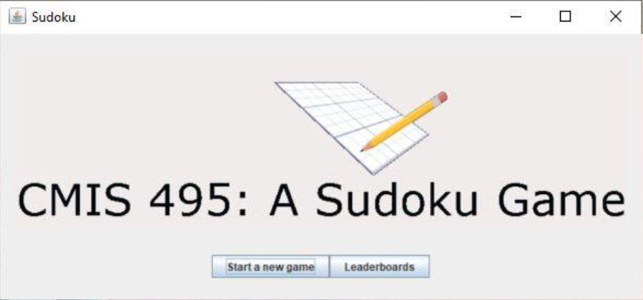

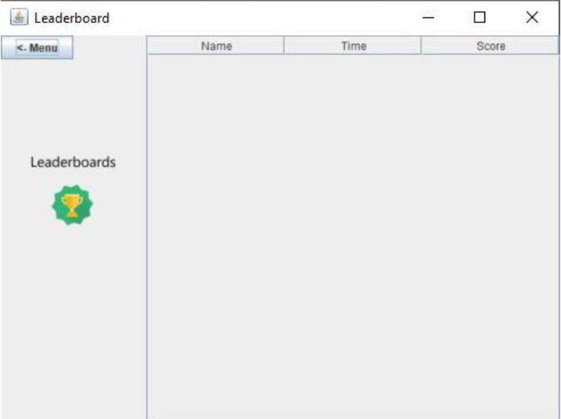

**Test Case 2: User starts and ends game; no leaderboard update**

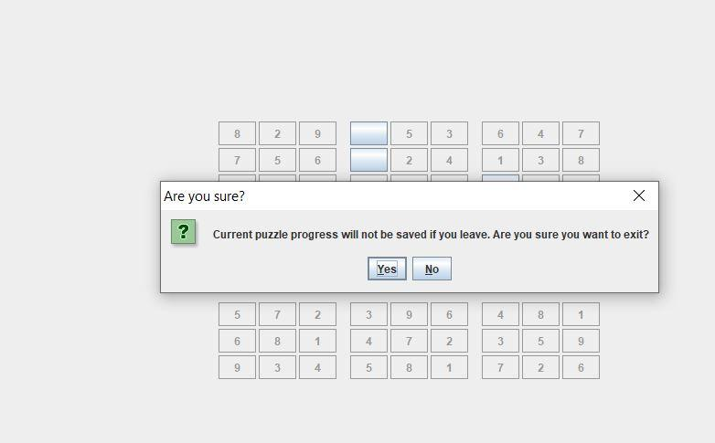



**Test Case 3: Partial game, incorrect entry, leaderboard not updated**

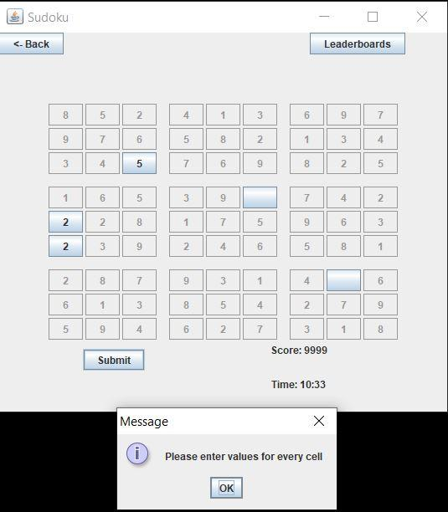

**Incorrect entry attempt (duplicate number attempt)**

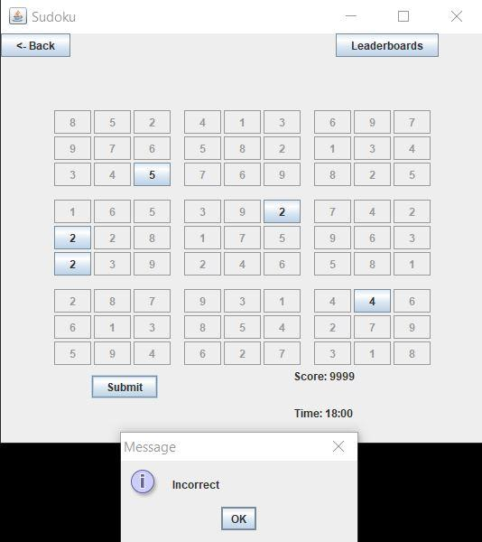

**Note: Game exited with no save warning; Leaderboard not updated.**

**Test Case 4: Multiple invalid name entries. Finally enters the correct name with the Leaderboard updated.**

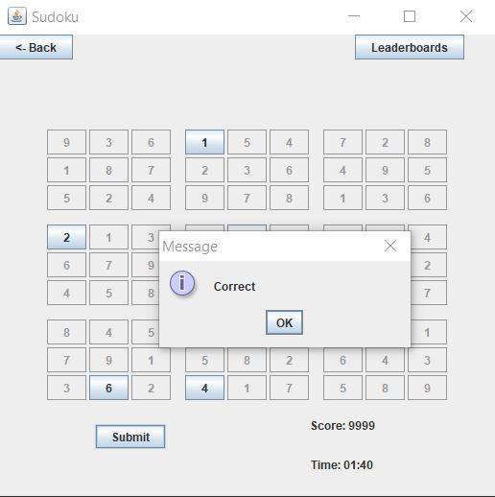

**Invalid name attempt**

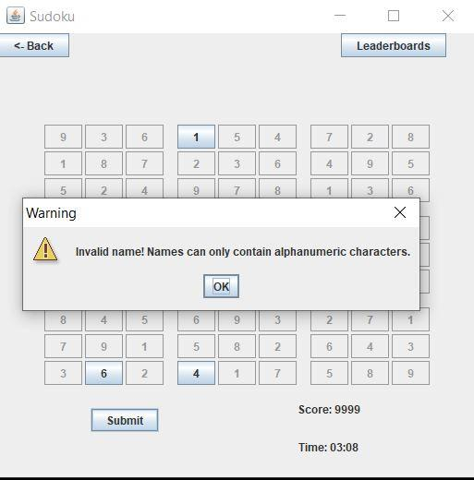

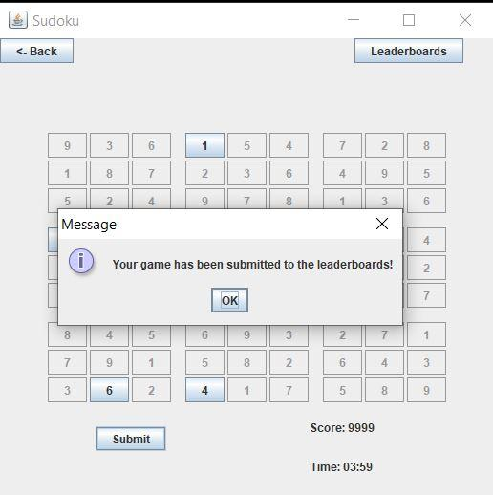

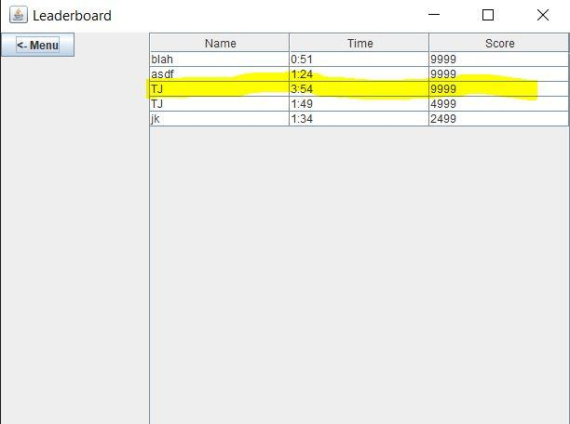

**Test Case 5: Single, full game; Username “SkyNet”**

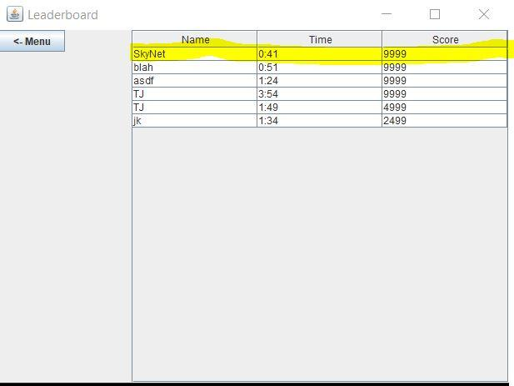

**Test Case 6: Multiple Users/Games run**

